Contain, control and eliminate
This document is part of the standard operating procedures (SOPs) for porcine epidemic diarrhoea (PED) and is identified as SOP 8.

Step 1: Contain the virus

Movement restrictions
Temporarily stop all animal movements on and oﬀ farm until the infection is under control. This includes other species as they could spread infection indirectly.
Stop all visitors, including:
- Deliveries
- Non-essential contractors
- Family
- Friends
- Neighbours
If it is essential for visitors to enter your farm, refer to PED SOP 4 Farmgate biosecurity – People.
Make your site as secure as possible and lock gates to prevent unauthorised access. This is especially important on outdoor units.
Make sure you have disinfection facilities at all entrances.

Line of separation
Establishing and enforcing a clear line of separation is essential to prevent the virus moving between clean and contaminated areas.
Implement the following measures:
- Enforce an imaginary (or actual) line around the unit which must not be crossed (refer to PED SOP 6 Farmgate biosecurity – Line of separation)
- Set up a Danish/bench entry for all staff and essential visitors (refer to PED SOP 4) and ensure everyone entering the farm uses it consistently
- Do not allow any clothing or boots to be removed from the farm

Deliveries
Stop all unnecessary feed deliveries while the outbreak is being managed. If deliveries are unavoidable, consider the following:
- Receiving bagged deliveries off-site, and ideally use on‐site vehicle to transport them onto the farm as required
- If feed vehicles must enter the farm, ensure it follows PED SOP 5 Farmgate biosecurity – Vehicles
- It is essential that drivers and vehicles do not carry away any infected pig faeces

Handling livestock, waste and equipment
Manage livestock, waste and equipment carefully to prevent further spread of infection.
Take the following actions:
- Limit direct contact with pigs
- Wear suitable PPE when handling pigs
- Always change and clean boots and overalls after use
- If deadstock collection is required, agree arrangements in advance with contractor (refer to PED SOP 9 Fallen stock)
- Do not allow any manure or slurry to leave the farm (refer to PED SOP 12 Manure management)
- Assume everything on the farm is likely to be infected – don’t remove anything from the farm without thoroughly cleaning and disinfecting it, such as tractors, trailers and farm kits

Step 2: Control and eliminate the virus

Early weaning
- During an acute outbreak, the youngest pigs will be dying in high numbers (expect 100% mortality)
- Wean piglets early (10–14 days) to improve survival rates, unless advised otherwise by your vet
- Consider additional temporary weaner accommodation
- Do not move pigs oﬀ-site, unless agreed with your farm vet, as this risks spreading porcine epidemic diarrhoea virus (PEDv)
- Piglets will require extra care – warmth, electrolytes and ﬂuids
- Euthanise any piglets that are unlikely to recover
- You need provision for storing deadstock, that is, sealed leak‐proof containers; on‐site incineration is the best option, but if not possible, refer to PED SOP 9 for further details

Herd exposure
- Exposure should happen as soon as possible after the outbreak is conﬁrmed
- The aim is to infect and recover all sows, gilts and boars in a short period to produce a uniform herd immunity and stop the virus shedding
- Suckling piglets in the early stages of infection, ideally within 18 hours of the onset of diarrhoea, are the best source of the virus
- Controlled exposure should only be carried out under the strict supervision of your farm vet, who should refer to the PVS Guidelines on Controlled Exposure, available on the PVS website (pigvetsoc.org.uk)

Farrowing room management
The goal is to reduce infection pressure and minimise the spread of PEDv between litters and farrowing rooms.

Biosecurity measures
- Set up room‐speciﬁc boots and overalls, disinfectant foot dips and handwashing facilities outside every farrowing room
- Allocate staﬀ to diﬀerent production areas, if possible, and do not allow crossover
- Use colour coding to demarcate which areas staﬀ can and cannot enter, e.g. using coloured tape and equipment (refer to Figure 1 for examples)
- Manage farrowing rooms as all‐in, all‐out systems
- Keep age groups within rooms as close as possible and do not move them between rooms

Piglet management
- Try to ensure all piglets receive enough colostrum
- Stop all cross‐fostering, leave all piglets with their mother or euthanise if they are not healthy
- By 24 hours after farrowing, euthanise weak or small piglets that are unlikely to survive or are suspected to have had low colostrum intake
- Stop all processing of piglets (for example, teeth clipping, tail docking, iron injections) until piglets are surviving to 7+ days of age
Processing rules
- Handle piglets individually, do not use barrows
- Use a clean needle for every litter
- Use clean gloves for every litter
- Use two sets of teething, tailing and tattooing equipment and rotate between litters, disinfecting when not in use
- Do not step into farrowing crates except when essential, e.g. at weaning
- Record and remove all dead pigs to sealed, leak‐proof containers as soon as possible
- Sows that have lost their entire litters should be left in the farrowing room until weaning; on veterinary advice, consider synchronising oestrus in these animals
- When weaning, try to move pigs individually rather than in a barrow
- Do not hold any piglets back at weaning; euthanise if not healthy
Once the farrowing room is empty, thoroughly clean and disinfect it, following PED SOP 11 Intensive cleaning and disinfection of units following PEDv breakdown; make sure you include all equipment, room‐speciﬁc boots, etc. and the hallways.
Heating the clean farrowing rooms can also be beneficial, as higher temperatures promote faster drying of surfaces and help reduce virus survival in the environment.
Figure 1. Examples of colour coded equipment to avoid cross contamination
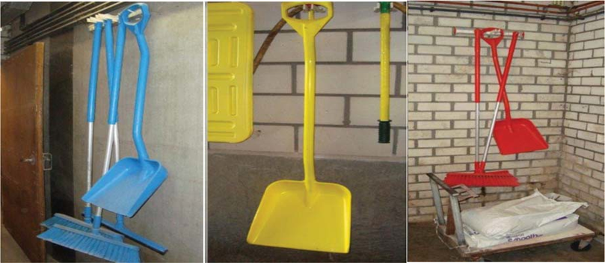

Farrowing paddock management in outdoor systems
The principles outlined in the farrowing room management section also apply to outdoor systems. In addition, you should also consider the following points when weaning pigs outdoors:
- Temporary accommodation will be required as you must not move pigs oﬀ-site unless agreed with your vet
- Remove farrowing beds from the paddock (this material may be used to expose pregnant animals to the virus but only under strict veterinary advice)
- Tip, wash and disinfect huts (refer to PED SOP 11) and relocate them in the paddock
- Thoroughly clean and disinfect drinkers, troughs and feeders that were in use
- Clean and disinfect livestock trailers after weaning

General considerations
- Maintain good record‐keeping, especially monitoring symptoms in sows, to track the spread of the virus and development of immunity; mortality records are also important
- Increase rodent baiting – inside and outside – to reduce the likelihood of virus being moved around by rodents
- Increase bird scaring on outdoor units
- You may need additional labour, such as your support teams, to help with the extra management tasks

Explore further resources on PEDv
These sources provide additional information and up‑to‑date guidance on PEDv:
- All SOPs are available on our website – ahdb.org.uk/PEDv
